**Algorithm**

Algorithm That I used is **Resnet** along with Pairwise learning.

Its working

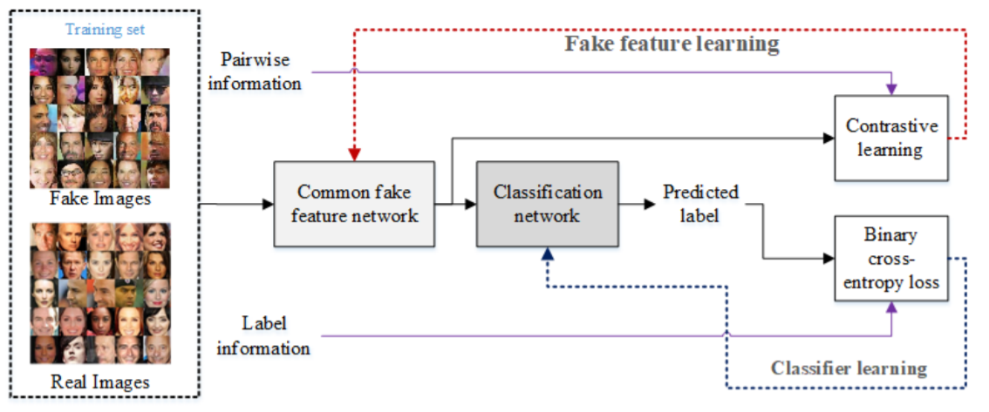

**Code Usage**

Steps to use the code-:

1. Type the command ***python train.py*** in the training folder.
2. This will generate a file named ***model.h5*** in that folder. Just copy that to production folder where test.py is present.
3. Now, move to the production folder and type the command ***python test.py***.
4. Now you have to give the path to the image file that has to be predicted and click enter.
5. You will get the prediction in the json file name ***final.json***.

**Caution:**  Check the paths in the code files.